**Technical Challenge – Android Development**

In the following portal you'll find different currency api's that allows to extract historical currency

Exchange rates.

<http://fixer.io/>

for example, this will show the exchange rate between USD & ILS in a specific date

<http://api.fixer.io/latest/2012-01-03?base=USD&symbols=ILS>

* Create a financial information app
* Display currency exchange rates for a specified date range for any 2 currencies
* The result should be displayed as either
  + a table with columns including the relevant information
  + or as a line graph using 3rd party library
* UI guidelines
  + Use flat design
  + Color schema – use white & black color schema to resemble fixer.io website
  + Logo – use fixer.io own logo from their website
  + UI elements
    - use a date picker to display and choose dates
    - make UI as friendly as possible to use and straight forward to understand
  + Make sure to incorporate proper client side validations for
    - From / to date validation
  + See the following wire framing for general UI direction  
    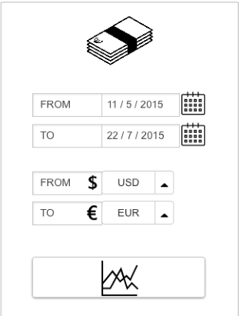
* Extras
  + Include a settings option to save preferred currencies
  + Add a share option to invite friends to download the app
* See further details below – read through before starting implementation
* Time that should be spent on the exercise – up to 4 hrs
  + If time is not sufficient to fulfill everything, its up to you to prioritize what to do and what not to do

**Technologies To Cover:**

1. Android / Java
   1. JSON
   2. HTTP
   3. Push Notifications
   4. Location
2. IDE – Android Studio
3. VCS – Git
4. Dependency Management - Maven

**The goal of the challenge is to write an enterprise grade app**

Develop an android app based on the above details and send a working apk that can be installed on an android device.  
Try to use most of the technologies mentioned above to some extent and as you see fit.

Guidelines :

1. Use freeware tools and services only
2. Create new accounts in all chosen platforms
3. You should be able to administer those accounts and provide access to them upon request

Expectations :

1. Coding Considerations
   1. All sources should be available in a public git repository
   2. Project will be developed in Android Studio IDE
   3. Development environment should be reconstruct able on a new machine, not only on your own machine (Including all dependencies)
   4. Properly documented
   5. Generate well formatted logs for debugging purposes
   6. Deal properly with input validation and data discrepancy